

Home Renting Application

Done by:

* Salah Eddine Salhi
* Hamdi Abderrahmene
* Baghdadi Mouad
* Selidja Raouf

***The selected technology choices:***

**Frontend**:

* + - Reactjs
    - Javascript
    - Html
    - Css

**Backend**:

* + Fastapi
  + Python
  + Sqllite

***The development environment:***

* VISUAL STUDIO

***Collaboration environments:***

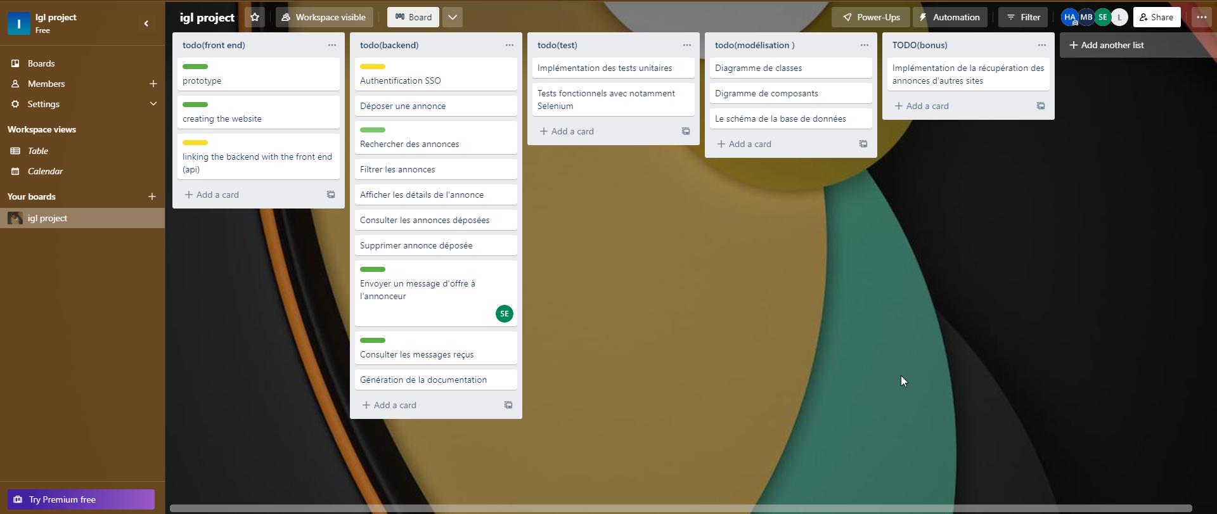

**1) Trello:**

**2) Github:1) Component diagram:**

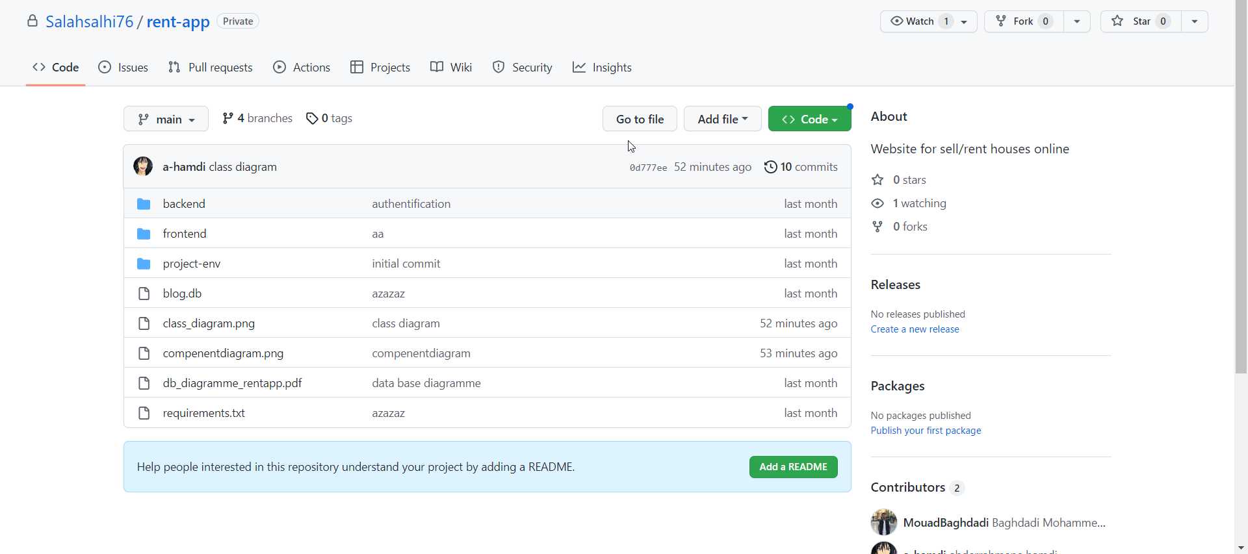

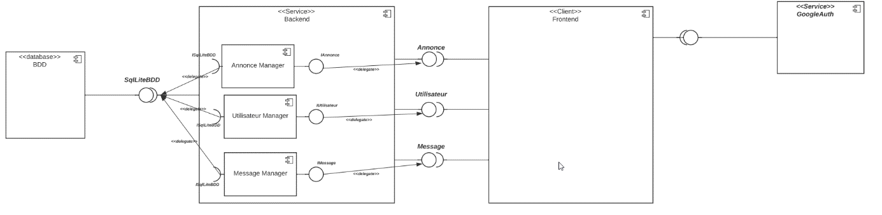

**2) Class diagram:**

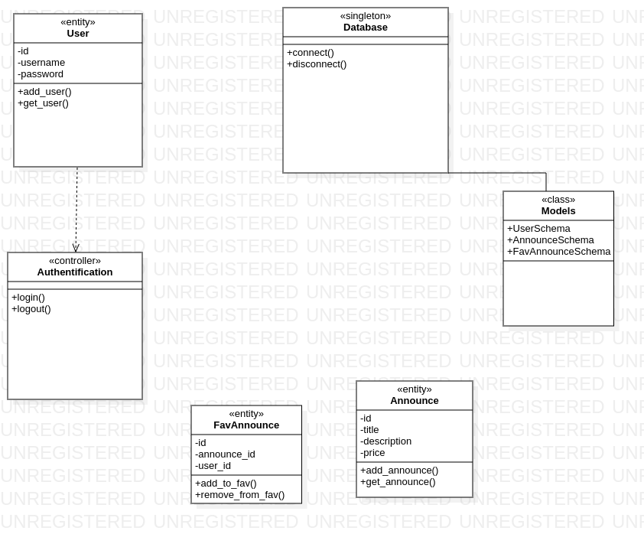

**3) Database schema**:

